**Special Rules for Upgrading to Controller Software Release 5.0.148.0**

http://www.cisco.com/en/US/i/templates/caut.gif

**Caution** http://www.cisco.com/en/US/i/templates/blank.gifBefore upgrading your controller to software release 5.0.148.0, you must comply with the following rules.

•http://www.cisco.com/en/US/i/templates/blank.gifMake sure you have a TFTP server available for the software upgrade. Keep these guidelines in mind when setting up a TFTP server:

–http://www.cisco.com/en/US/i/templates/blank.gifController software release 5.0.148.0 is greater than 32 MB; therefore, you must make sure that your TFTP server supports files that are larger than 32 MB. Some TFTP servers that support files of this size are tftpd32 and the TFTP server within the WCS. If you attempt to download the 5.0.148.0 controller software and your TFTP server does not support files of this size, the following error message appears: "TFTP failure while storing in flash."

–http://www.cisco.com/en/US/i/templates/blank.gifIf you are upgrading through the service port, the TFTP server must be on the same subnet as the service port because the service port is not routable, or you must create static routes on the controller.

–http://www.cisco.com/en/US/i/templates/blank.gifIf you are upgrading through the distribution system network port, the TFTP server can be on the same or a different subnet because the distribution system port is routable.

–http://www.cisco.com/en/US/i/templates/blank.gifA third-party TFTP server cannot run on the same computer as the WCS because the WCS built-in TFTP server and the third-party TFTP server require the same communication port.

•http://www.cisco.com/en/US/i/templates/blank.gifYou can upgrade or downgrade the controller software only between two releases. To upgrade or downgrade beyond two releases, you must first install an intermediate release. For example, if your controller is running a 4.1 or 4.2 software release, you can upgrade your controller directly to software release 5.0.148.0. If your controller is running a 3.2 or 4.0 release, you must upgrade your controller to an intermediate release prior to upgrading to 5.0.148.0. [Table 1](http://www.cisco.com/en/US/docs/wireless/controller/release/notes/crn501480.html#wp233863) shows the upgrade path that you must follow before downloading software release 5.0.148.0.

|  |  |
| --- | --- |
| Table 1 Upgrade Path to Controller Software Release 5.0.148.0 | |
| **Current Software Release** | **Upgrade Path to 5.0.148.0 Software** |
| 3.2.78.0 or later 3.2 release | Upgrade to a 4.1 release before upgrading to 5.0.148.0. |
| 4.0.155.5 or later 4.0 release | Upgrade to a 4.1 or 4.2 release before upgrading to 5.0.148.0 |
| 4.1.171.0 or later 4.1 release | You can upgrade directly to 5.0.148.0. |
| 4.2.61.0 or later 4.2 release | You can upgrade directly to 5.0.148.0. |

Screen Shots:

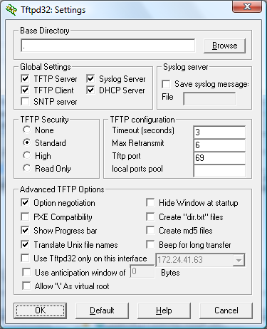

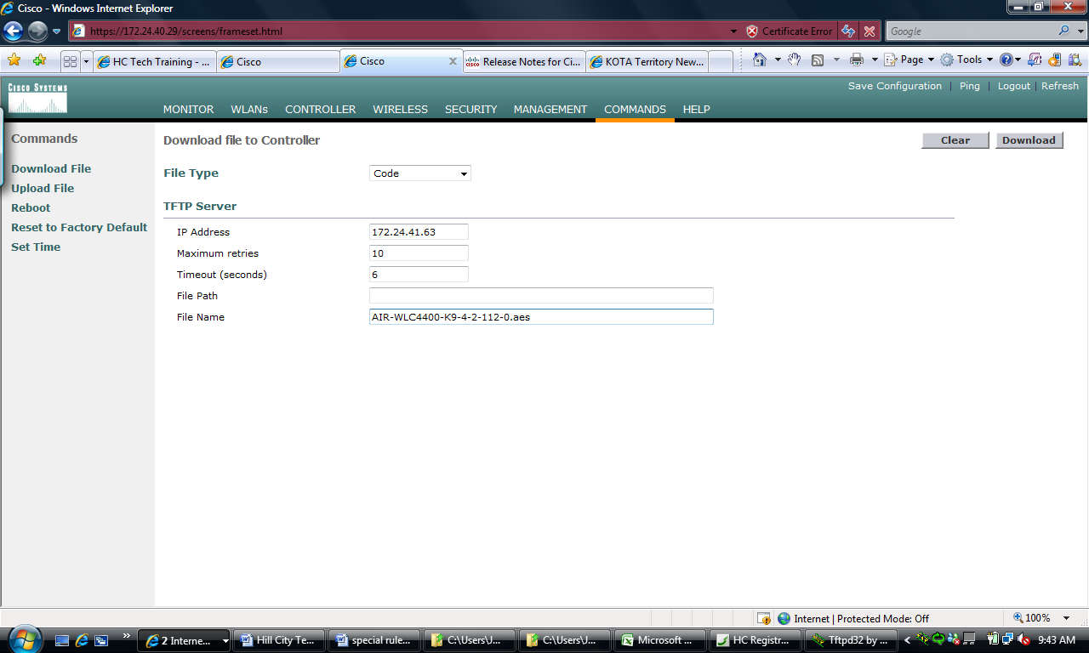

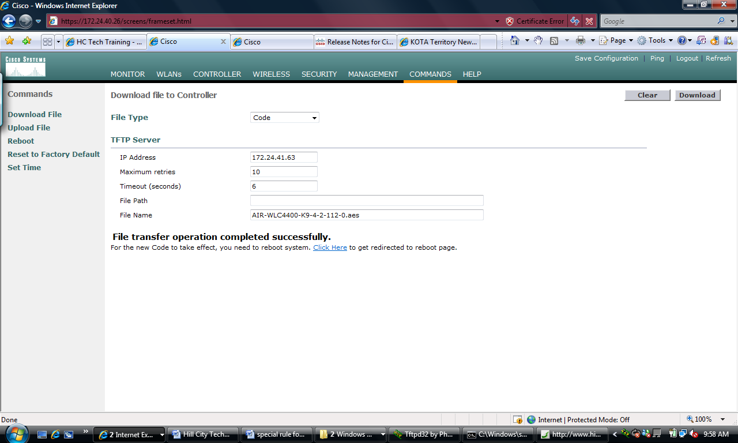

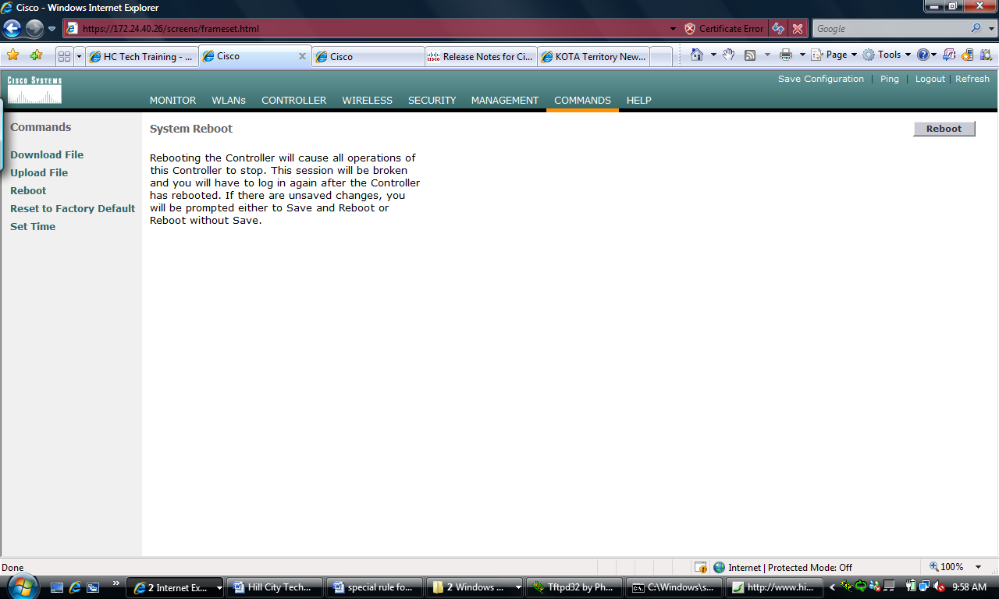

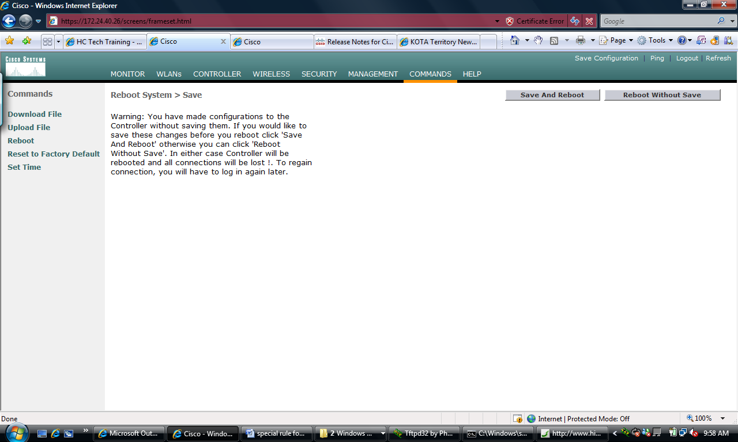

Creating WLANS

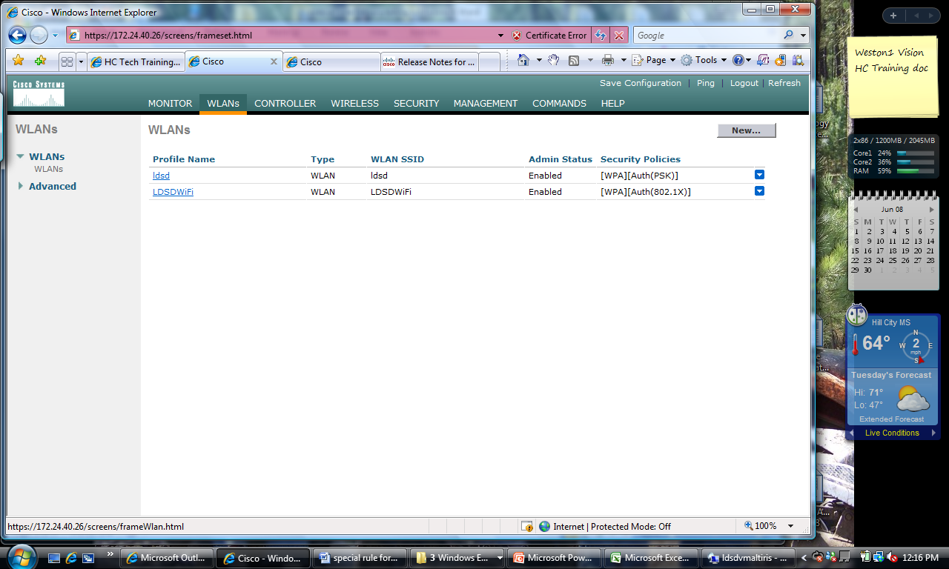

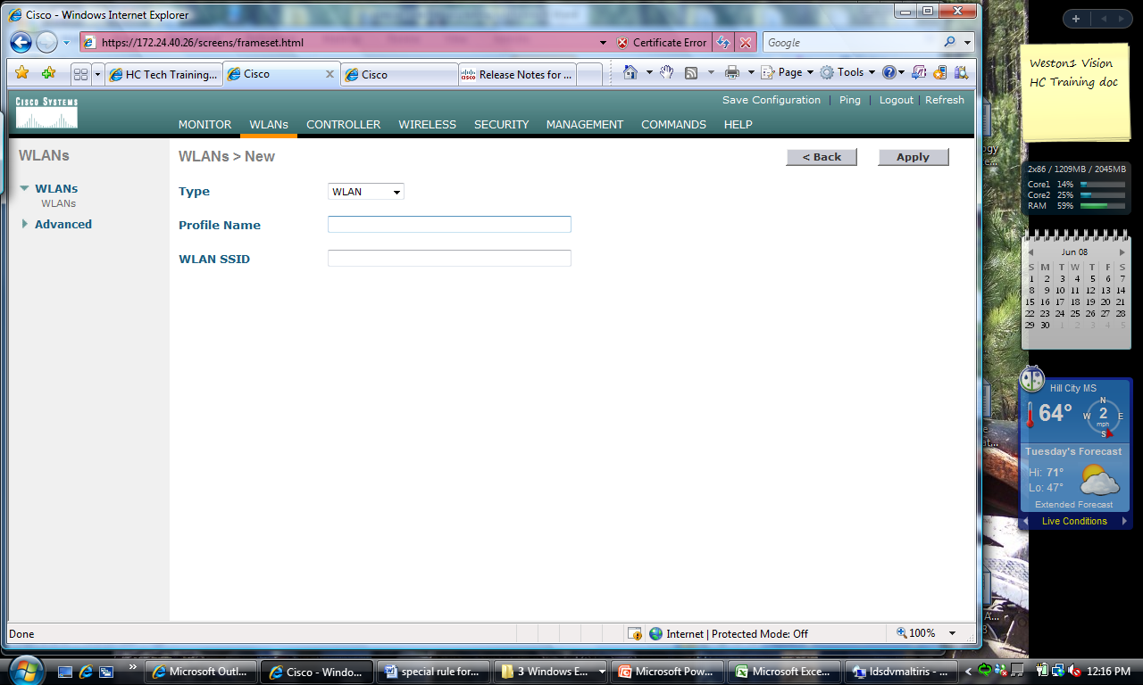

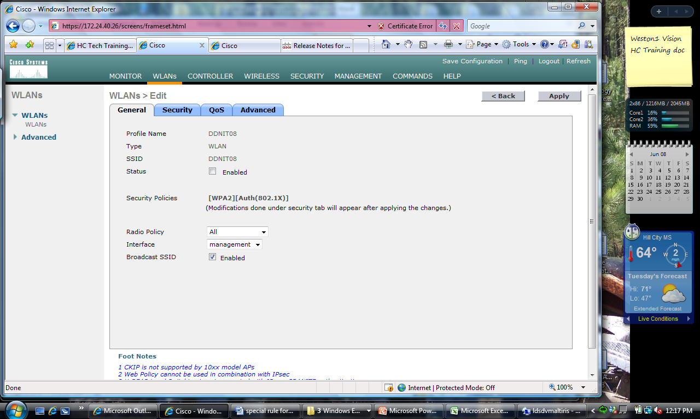

Uncheck Broadcast SSID

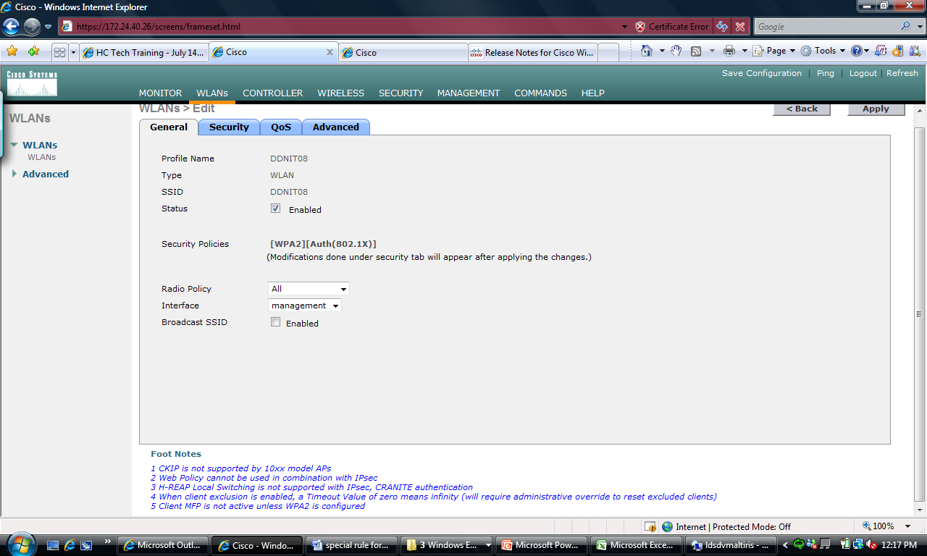

WPA+WPA2 security

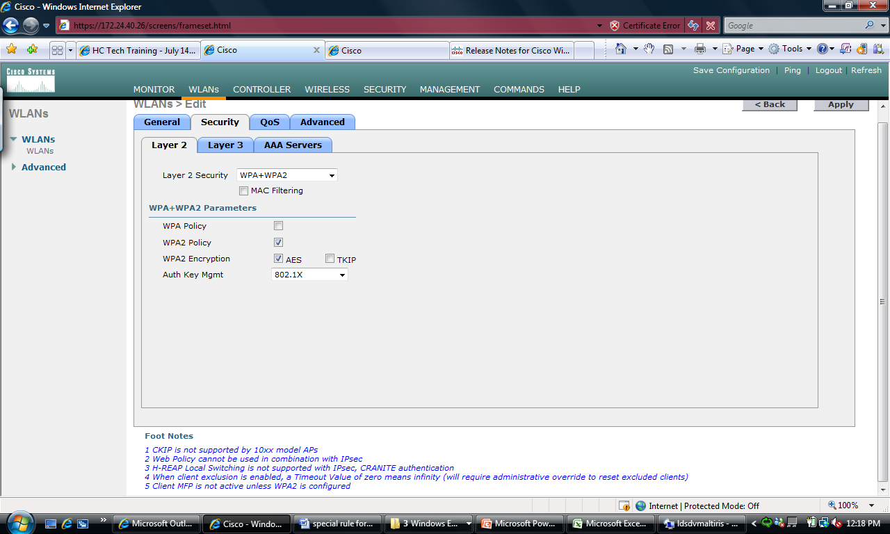

Connect to AAA servers

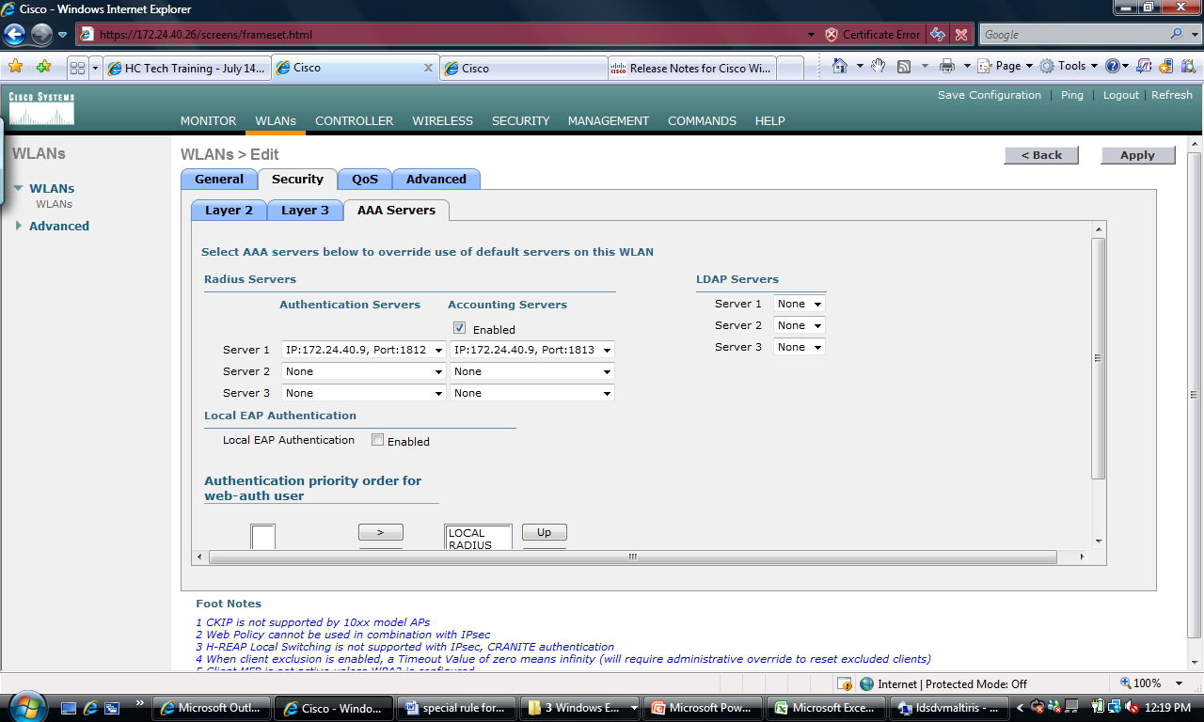

Remove check from Client Exlusion

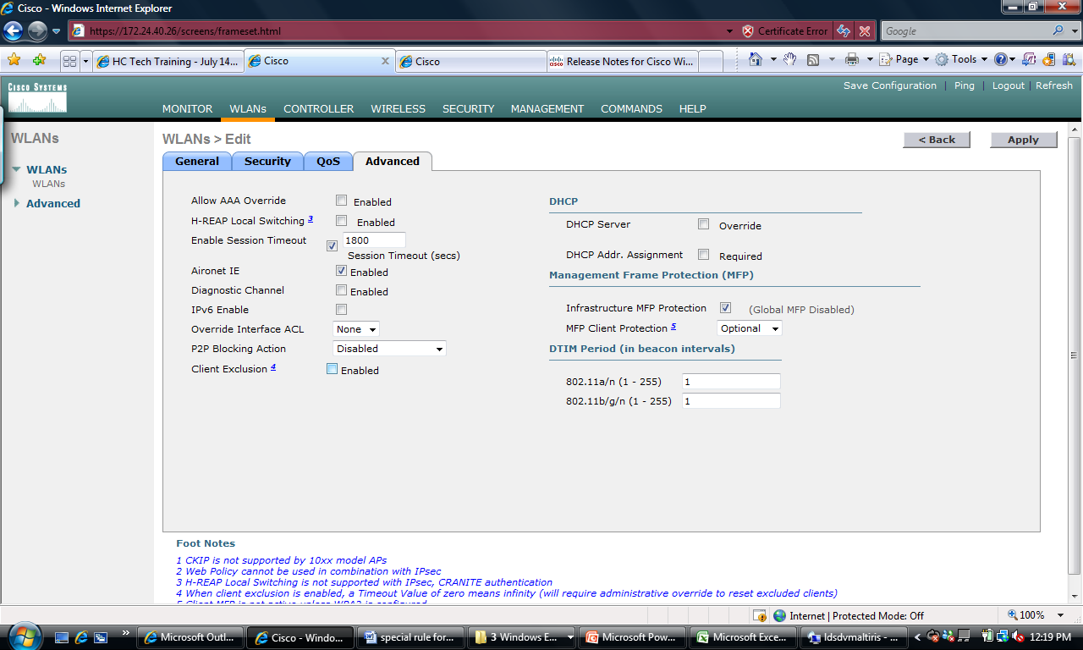

OK when you apply the WLAN

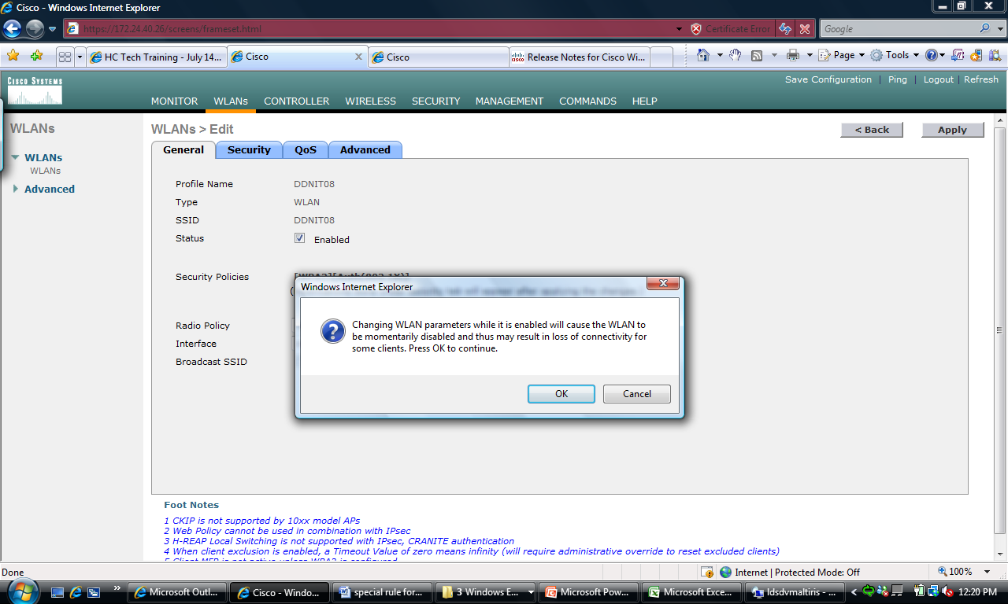

Ethernet Multicast Mode to support SynchronEyes

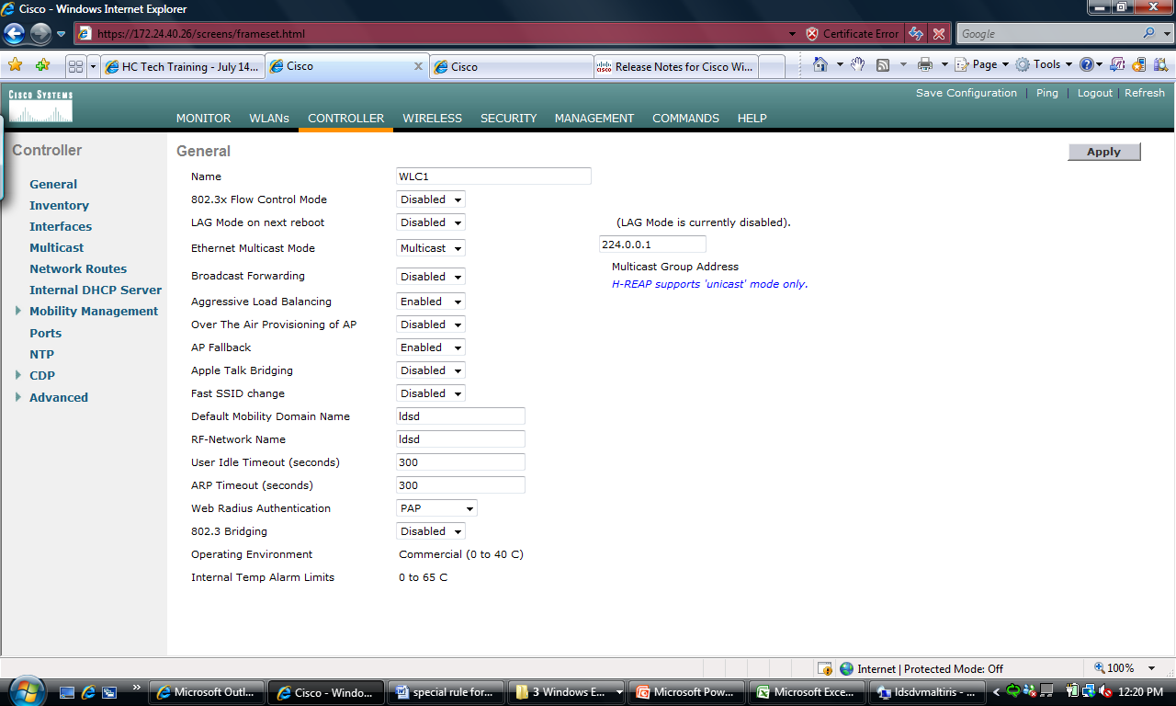

Enable 45 clients per AP

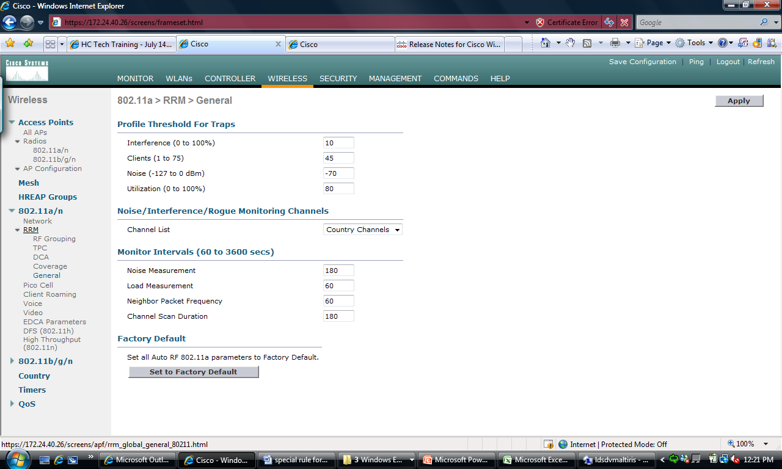

Add Radius Authentication

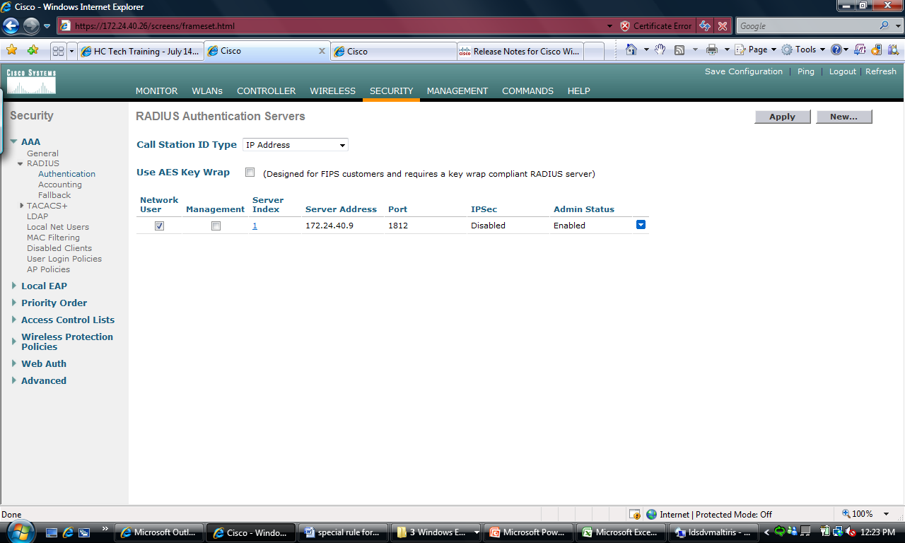

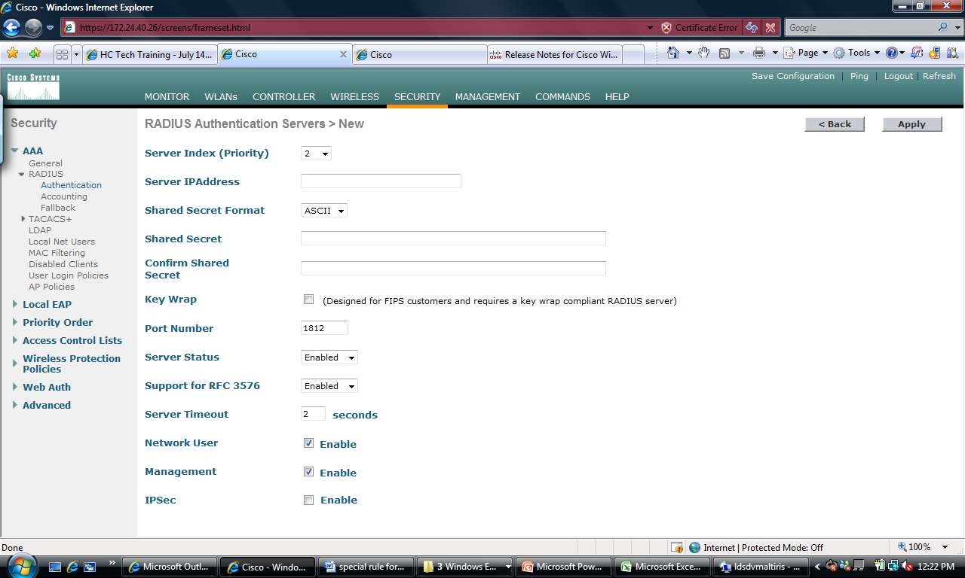

Add RADIUS Accounting

